Grooming the pet Havanese
You may have heard that the Havanese is non-shedding. The reality is that all dogs shed to some degree. Some more, some less. While the Havanese does not traditionally shed as some breeds do, he certainly will lose some coat in the hair brush, and where he rubs against furniture or rolls on carpets etc. The Havanese looses coat similarly to how you lose your hair. The Havanese would perhaps more accurately be described as low shedding. Low or minimal shedding does not mean no-maintenance. Your Havanese will benefit from frequent grooming sessions several times a week. Routine grooming helps to keep your dog's skin, coat, teeth, gums and nails in peak condition. As well as generally improving your pet's overall appearance , grooming also provides you with an excellent opportunity to examine the skin and coat for early signs of problems such as parasites, foreign bodies, skin disorders, matts, growths and wounds. The procedure outlined here follows the recommendations of a Certified Master Groomer and should be suitable for the majority of pet Havanese.
Good grooming behaviour should start at an early age, as soon as you acquire your puppy. Begin by getting it used to being placed on a steady table for grooming. Use a rubber backed mat, small carpet or towel to prevent slipping. Teach your puppy to lie down and/or stand quietly and to relax and enjoy your undivided attention. Scratching the ears or chest may help to sooth an anxious pet, while a hand under a young puppy's stomach provides support and promotes confidence as you gently brush through the coat. This early training taught by repetition, correction and praise is important to ensure that your dog learns to accept grooming and thinks of it as a pleasant experience. You may if you wish, reward good behaviour with a small treat at the end of each grooming session.

Brushing and combing
Brusing and combing your dog's hair several times a week is the best way to keep the coat in good condition. On long-haired breeds like the Havanese brushing removes the dead hair before it has a chance to mat and also serves to stimulate the growth of new hair and to help to distribute natural oils throughout the coat. It also acts as a gentle massage that improves muscle tone and circulation.
Equipment - Small soft slicker brush, Pin Brush, Combination Comb, Flea comb, Conditioner
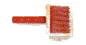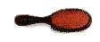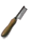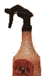
Most Havanese spend the majority of their time inside the house. Unfortunately, the combination of artificial heat, air-conditioning, dry atmosphere and static electricity may result in coat damage or an assortment of skin problems. Spraying the coat with coat dressing, conditioner or diluted creme rinse before brushing may help to prevent dryness and static buildup and also adds a lovely sheen to the coat. For most pet grooming, a smooth tipped pin brush or soft wire slicker brush will be the tool of choice. Choose a soft brush to avoid scratching or irritating the skin. Many people use a pin brush to minimize coat breakage, and reserve the slicker for grooming the feet or tangled areas only. You may use the slicker all over if you wish but there will be some coat damage due to hair breakage. Which ever brush you choose, brushing must be done thoroughly but gently. The most efficient method is line brushing where the entire coat is brushed in layers from the skin out. This is usually easiest if the dog is lying on its side. With one hand, the hair is parted to the skin and held down while the other hand gently brushes through the hair below the part. Once this section is smooth and tangle free, another section of hair is pulled down along the part and groomed in the same way. You may need to moisten each layer with a light mist of conditioner or coat dressing before brushing.
The Havanese have an abundance of hair around the face. If any food or dry matter have accumulated in the facial hair or beard, you should start your grooming session by working in some liquid tangle remover or conditioner into the soiled hair. During the time that it takes to brush the body, the tangle remover has a chance to soften and loosen the debris that was caked on, thereby making it much easier to remove.
With the dog laying on its side start by line brushing the front and hind legs on that side. Then proceed to line brush the body coat until you reach the backbone. Turn the dog over and repeat the procedure on the other side. If you prefer, you can also reverse this procedure by starting at the backbone and working down to the legs. You may find one way easier than the other. The order does not really matter so long as all parts of the dog are brushed and combed thoroughly. The chest and stomach area can be reached by lifting the dogs front leg or by rolling it onto it's back. Finally, with the dog sitting or standing, brush the head, chest, neck, top of body and the tail. Unlike many other long coated breeds, the Havanese coat should not be artificially parted in a perfect straight line along the spine. Rather, you should allow the coat to fall on its own. A long, heavy or profuse coat may part naturally. Comb out the face, corner of the eyes and beard, using the teeth on the fine end of the comb or use an extra-fine facial or flea comb. If the beard was pre-treated with tangle remover , it should comb out easily. After the hair has been completely brushed ; take the medium/coarse end of the comb and run it through the coat to make sure that all mats and tangles have been removed. If your Havanese has a curly coat you may find it easier to use a wide tooth poodle comb. Any mats or tangles that you encounter should be saturated with conditioner then teased out gently rather than pulled or cut out. You have a few options for what to do with the head furnishings. The hair may be simply brushed back and allowed to fall naturally or it may be parted in the centre and then combed to the sides or braided into a single plait on either side; creating a lovely frame for the bright eyes and endearing expression. Other options are to gather up the hair into a simple topknot or to fasten it back with barrettes or small clips. On a pet only, you may choose to trim the fall to a shorter length.

Cleaning the eyes and ears
Gently bathe the skin around the eyes using a moistened cotton ball or soft wash cloth. White or light-coated Havanese may get discoloured hair near the eyes and mouth. Daily cleaning will help control this staining. A soothing eye lotion (available from your vet or pet supply store) helps to ease eye irritation. A few drops applied to the stained area may help to neutralize and remove the discolouration. Assorted grooming products from your pet store or groomer are also available to camouflage the staining. See your Vet for other treatments for this problem if it is severe or very unsightly. Excess tearing and subsequent staining can also be due to all the minerals and other impurities found in tap water. Switching to filtered or distilled water in the water dish can make a dramatic difference. It can take up to 3 months to see the best results but improvement may be noted in as little as a few weeks.
As with all dogs with heavily feathered long pendant ears, problems can arise if the ears of your Havanese are not cleaned regularly. Hold open the ear with one hand and gently clean inside the ear flap with a moistened cloth or cotton ball. Do not probe too deeply inside the ear canal. The hair growing inside the ear should be regularly plucked out, a few hairs at a time using your fingers, tweezers or a haemostat. It is important to use a fresh cotton ball or a clean corner of the wash cloth for each eye and ear.

Cleaning the teeth
Just like human beings, dogs teeth accumulate plaque which can harden into tartar. If the teeth are neglected, bacteria can grow causing infections. Regular brushing can help to maintain a dogs teeth and gums as well as keeping the breath fresh. You should brush the teeth 2-3 times a week. If you start at a young age by scratching the muzzle and handling the mouth you should soon be able to rub the teeth and gums with your finger. Then you should be able to easily progress to gently brushing the dogs teeth with a small soft toothbrush or finger brush. Never use human toothpaste as it contains detergent which will froth in the dog's mouth and, if swallowed, may upset the stomach. A better alternative is to use a canine toothpaste. This special enzymatic toothpaste is available from your veterinarian or pet supply store in an assortment of palatable flavours like chicken, liver and malt.

Trimming the nails
The nails will grow too long if left unattended. Most dogs hate to have their nails clipped, but if you start when the dog is young he should learn to accept it as part of the grooming routine. 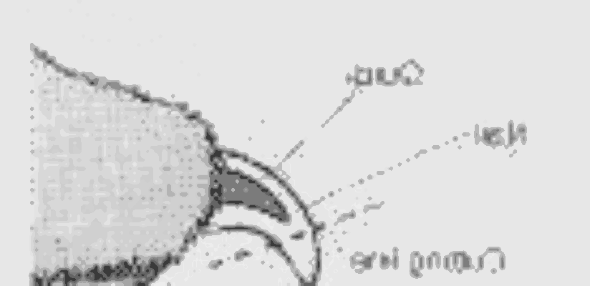Clip the nails carefully, a little at a time, taking care not to cut the quick. Then smooth any rough edges with an emery board or nail file. If you are having great difficulty with this task, you may need to see your groomer or Vet for regular nail care.

